Sample Driver Safety Manual

The following rules and policies are meant as a guideline and do not cover every possible item or situation. Contact your manager or our safety staff if you have additional questions or concerns. We ask you to read the manual, then sign, date and return this Statement of Acknowledgment.

_______________, President

Statement of Acknowledgement

I have read the _____________ Driver Safety Manual and understand the information contained in this document. I acknowledge that I will be held accountable for complying with all rules and policies stated here. Additionally, my
compliance with these policies is a part of my job and is a condition of my employment. I agree that this document does not constitute an employment contract.

__________________________ __________________________ _______________
Driver Name Driver Signature Date

Driver Qualification/Eligibility ______Initials
- Drivers must possess the required license to operate the vehicle assigned. (Provide license requirements for your operations – proper class or CDL)
- Drivers must have at least three years of total driving experience and at least two full years of experience driving the type of vehicle assigned. (Typically, more experience/knowledge is required for operating specialized vehicles, hauling unique cargo, pulling trailers, or operating in unique environments such as large cities or mountains. These experience/knowledge requirements should be listed.)
- Drivers must maintain an acceptable motor vehicle driving record (MVR).
  - No drug- or alcohol-related violations, such as driving under the influence (DUI) or driving while intoxicated (DWI), in the last five years.
  - No major violations in the last three years.
  - Minor moving violations and at-fault collisions (combined):
    - No more than three in the past three years.
    - No more than two in the last 12 months.
Major Violations (examples) | Minor Violations/Accidents
- Excessive speeding — 15 mph or more over the posted speed limit  - Racing or exhibition driving  - Careless/reckless/imprudent driving  - Attempting to elude a police officer  - Failure to stop/report an accident  - Making a false accident report  - Failure to stop for a school bus  - Vehicular homicide, manslaughter or assault resulting from a vehicle-related incident | - Any moving violation not listed under major violations  - Non-moving violations are not typically counted but should be reviewed individually as some may indicate a disregard for safety  - All accidents, except:  - Verifiable not-at-fault accidents  - Animal collisions  - Broken windshields
Note: A violation received because of an accident would be considered one incident

- DOT-regulated drivers must maintain an acceptable Preemployment Screening Program (PSP) record.
- Drivers must be physically able to safely operate the vehicle assigned with or without reasonable accommodations. Drivers operating DOT-regulated vehicles must be medically qualified in accordance with the regulations, with medical requalification every two years.
- DOT-regulated drivers must also meet qualification requirements:
  - Interstate drivers as outlined in § 391.11 General qualifications of drivers.
  - Intrastate drivers as outlined in state regulations.
- Drivers must immediately report license suspensions, revocations and other restrictions and cease driving.
- All new moving violations must be reported by the next business day.
- DOT roadside inspection reports must be reported upon first return, but no more than 24 hours after each inspection.
- Management reserves the right to vary qualifications as needed due to unique situations.

Vehicle Use and Restrictions ______Initials
- Only authorized drivers may drive a company vehicle or drive their own vehicle on behalf of the organization.
- Drivers may only use company vehicles for legitimate business purposes.
- Only authorized drivers may take vehicles home at night. Personal use of vehicles beyond that is prohibited.
- Only employees or customers may ride as passengers in company vehicles or employee vehicles while operating on company business. No hitchhikers are permitted
Distracted Driving ______Initials
- Phone use
  - Drivers are prohibited from making or receiving phone calls unless safely parked or it is an emergency.
  - Drivers are prohibited from texting, browsing the internet, interacting with social media, etc., even if the interaction is hands-free. This includes voice-to-text messaging.
  - Smart phones should be set-up to:
    - Notify the caller or texter that you are driving and will respond when safely parked.
    - Go directly to voicemail.
  - Ask a co-worker riding in the vehicle to take or make a call for you.
- Drivers should limit other distracting activities while the vehicle is in motion. This includes, eating, reading, reaching for objects and interacting with vehicle infotainment systems.
  - Set-up navigation systems, plug-in your phone, and set up your music before leaving.
  - Keep items you may need nearby so you are not reaching for them.
- Keep your eyes primarily focused on the forward roadway.
  - Mirror checks should be frequent but of a short duration – about one second.
  - Return your eyes to the forward roadway before checking another mirror.
Important Note: Phone Use
Organizations need to clearly determine their phone policy. We recommend a clear no-phone use policy, including no hands-free use, as outlined above. However, if you have no intent of enforcing a no-phone use policy you should not make it a rule as it could be used against you in an accident (failure to follow your own policy). As an alternative to a no-phone policy the following two bullets can be considered.

- Hands-free business calls may be made or accepted on a limited basis and of a limited duration if they are of an urgent nature and pulling over to a safe parking area is not practical.
- Initiation or acceptance of hands-free calls should be limited to one click – a DOT requirement.

Fatigue/Illness/Drugs and Alcohol ______Initials
- Drivers should be well rested, healthy, and alert before beginning any trip.
- Drivers should plan periodic rest breaks into their schedule to reduce fatigue. Generally, a driver should not drive more than two hours without taking a short break.
- Drivers should be aware of their total time on-the-job and stop driving when they become drowsy or fatigued.
- DOT-regulated drivers must comply with applicable hours-of-service requirements.
- Drivers should stop driving and find a safe place to park if an illness or stressor renders them incapable of driving safely.
- Drivers should be aware of the impact of an over-the counter drug or prescribed medications on his or her driving and follow precautions outlined, including not driving. Inform doctors of your driving responsibilities when receiving any new medical recommendation.
- Being under the influence of alcohol or a controlled substance is prohibited while operating a company vehicle.
- Consumption of alcohol by drivers during working hours or within 4 hours prior to driving is prohibited.
- Possessing controlled substances or open containers of alcohol in a company vehicle is prohibited.
- Drivers must comply with our company’s drug and alcohol program.
Defensive Driving ______Initials
Drivers should drive in a defensive manner, including the following:
- Maintain a safe speed, adjusting for traffic, road and weather conditions.
- Maintain a cushion of safety around your vehicle with an emphasis on proper following distance.
  - A minimum of three seconds is required for light vehicles with additional distance needed for larger vehicles, when pulling trailers, or in poor traffic/road/weather/visibility conditions.
  - Allow tailgaters to pass you.
  - Stay out of the blind spots of other vehicles.
- Scan ahead to identify hazardous conditions or actions of others and be prepared to stop.
- Yield to the right-of-way of others. This includes stopping at intersections and not pulling out in front of others.
- Anticipate unsafe actions of others, such as: not stopping where required, pulling out in front of you, or driving distracted. Cover your brake and be prepared to slow or stop. Distance your vehicle from distracted drivers.
- Be extremely cautious when driving around pedestrians and bicyclists. Pedestrian-related auto accidents are on the rise, partially attributed to pedestrians being distracted on their smartphones.
- Limit lane changes and passing.

Vehicle Inspections and Maintenance ______Initials
- Drivers are required to conduct a daily inspection of their vehicle with special emphasis on lights, turn signals, and tires. Monthly documented inspections are required using our inspection form.
- Defects should be reported immediately and discussed with maintenance to determine the vehicle’s status for safe operation. Drivers should not operate vehicles deemed unsafe until repairs are made.
- Drivers should ensure their designated vehicles are maintained in accordance with manufacturer’s requirements. Records of driver-initiated maintenance and repairs should be reported/submitted.
- In addition, DOT-regulated vehicle drivers are required to:
  - Complete daily pre-trip and post-trip inspections.
  - Ensure their vehicle and trailer have valid annual inspection stickers.
  - Turn in DOT roadside inspection reports when returning to base or no more than 24 hours after each inspection.
  - Not operate a vehicle that has been placed out-of-service by the DOT until repairs or conditions have been corrected.
Additional Driver Rules and Responsibilities ______Initials
- Drivers will operate the vehicle in a manner consistent with reasonable practices, to avoid abuse, theft, neglect or disrespect of the equipment.
- Seatbelt and shoulder harness use is required for all drivers and passengers.
- Drivers should adhere to local, state and federal traffic laws.
- Drivers are required to pay fines for any violations received.
- Smoking is prohibited in company-owned vehicles.
- Drivers are required to attend all driver safety meetings and review safe driving materials provided by the company.
- All vehicle safety systems, telematics, and dash-cams must remain on at all times unless specifically authorized to turn them off or disconnect.
- Vehicles should be parked in safe locations, keys removed, and locked. Valuable cargo should be removed or adequately secured from theft.
- Cargo securement
  - Smaller and “loose” items should be placed in containers, compartments, or tarped.
  - All cargo should be secured from movement with the following general principles applied:
    - Cargo securement systems (tie-downs, binders, etc.) should be in good repair and rated for at least twice the weight of the load.
    - A minimum of one tie-down device for loads under five feet.
    - A minimum of two tie-downs for loads over five feet with an additional tie-down for every 10 feet of cargo length thereafter.
    - A minimum of two tie-downs for loads over 1,100 lbs (500 kg).
    - For tracked or wheeled equipment, a minimum of four tie-downs with each tie-down’s capacity at least 50% of the entire load weight. The parking brake on the equipment must be set to prevent movement.
  - For DOT-regulated vehicles (over 10,000 GVW including trailer) and oversized loads drivers must refer to DOT securement requirements.
  - All loads extending beyond the width of the trailer or height of the vehicle need approval before transporting as permits may be required.
- Trailer safety
  - Only trained and authorized drivers may pull trailers.
  - Depending on vehicle and trailer size, as well as state(s) operated, a driver may need to be DOT qualified or possess a CDL to pull a trailer.
  - Drivers should ensure the towing vehicle’s towing and hitch capacities are adequate for the trailer and load to be pulled.
  - Additional driving precautions should be taken including reducing speed and increasing following distance.
Roadway Emergency Stops
Stopping along a roadway is dangerous and should only be done in an emergency, such as a breakdown.
- When possible, get off the roadway as soon as possible using your four-way flashers to warn other vehicles of your reduced vehicle speed.
- If you must stop:
  - Move as far off the roadway as safely possible, being aware of soft or sloped shoulders.
  - Try not to stop on a curve or other areas where it will be difficult to be seen by other motorists.
- Turn on your emergency flashers and put out reflective safety triangles as depicted below.
- Contact maintenance for direction on what to do.
- Do not work on your vehicle. Have the vehicle towed to a safer location to complete the repairs.
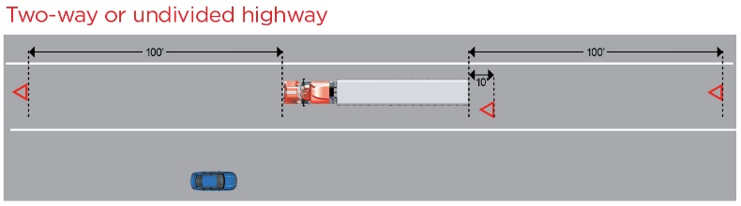 | 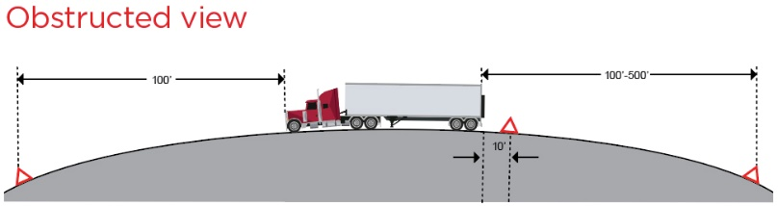
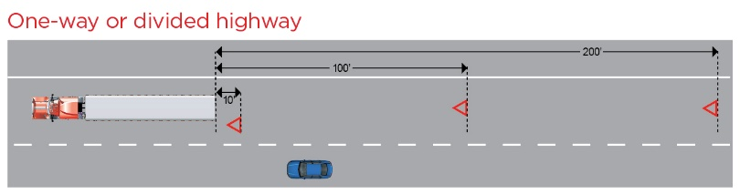 | 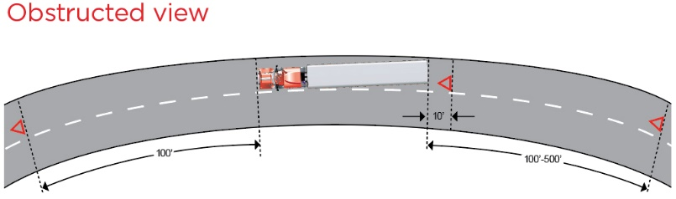

Accidents ______Initials
- Drivers are required to report all accidents and vehicle/cargo vandalism or theft immediately.
- Accidents should be reported to:
  - Primary - ________________________, ###-###-##### After Hours: ###-###-#####
  - Alternate - _____________________, ###-###-##### After Hours: ###-###-#####
- Follow these at-scene instructions:
  - Stop, turn off your engine, set your brake, and turn on your emergency flashers.
  - If the accident is minor and there are no serious injuries, move your vehicle to a safe place off the roadway.
  - Call 911 to alert police and other emergency personnel.
  - Put on your reflective vest. Set out your reflective triangles or flares.
  - Protect your cargo. If hazardous materials are involved, refer to the guidelines in your Emergency Response Guidebook.
  - Give the police complete and accurate information; do not guess. Do not discuss the specifics of the accident with other drivers or anyone else without our company’s approval.
  - Do not admit fault or accept offers to settle.
  - Do not sign anything without our approval.
  - Stay at the scene until police or we release you.
  - Accident scene photos:
    - Accident photos should be taken of the scene as soon as practical to help substantiate what happened, preferably before vehicles are moved. However, they should only be taken if it is safe to do so, depending on road and traffic conditions.
    - Photos to document vehicle damage can be taken after vehicles are moved to a safe location.
    - Photo Tips:
      - Get the entire scene and surrounding area:
        - From 100’ away, 50’ away and close-up
        - Take photos from all directions
      - Vehicles
        - All sides
        - Damaged areas
        - License plates
        - Company name, DOT#
      - Skid marks, traffic control devices and signs, etc.
Employee-Owned Vehicles ______Initials
- Employees must be authorized by management before they may utilize their own vehicle on behalf of the company.
- Drivers are required to adhere to the applicable policies set forth in this manual.
- Additionally, the following policies apply:
  - Proof of vehicle ownership is required. Providing a copy of the state registration card is adequate.
  - Insurance requirements:
    - The driver is responsible for all accidents occurring with his or her vehicle. ___________ assumes no responsibility for any loss or damage to the employee’s personally owned or leased vehicle or for any loss or damage to the employee’s personal property.
    - Employee drivers must provide and maintain current proof of insurance (POI) with minimum limits of at least: $300,000/$500,000/S100,000 (bodily Injury per person/bodily injury per accident/property damage.)
    - The insurance policy should include no exclusions for business use of the vehicle.
    - ______________ should be listed as “additional insured” on the policy.
    - POI is required initially and at time of renewal; submitted to ____________________.
  - Vehicle inspection and maintenance
    - Vehicles should be in good condition and less than 10 years of age and less than 150K miles.
    - Vehicles should be maintained according to manufacturer guidelines and records of maintenance and repairs retained by the employee.
    - Drivers are required to conduct a daily inspection of their vehicle with special emphasis on lights, turn signals, and tires.
    - Monthly documented inspections are required using our inspection form.
    - An annual inspection must be completed by a qualified mechanic.
    - Monthly and annual inspections should be submitted to___________________.

The information presented here is intended to help users address their own risk management and insurance needs. It does not and is not intended to provide legal advice. Nationwide, its affiliates and employees do not guarantee improved results based upon the information contained herein and assume no liability in connection with the information or the provided suggestions. The recommendations provided are general in nature; unique circumstances may not warrant or require implementation of some or all of the suggestions. Nothing here is intended to imply a grant of coverage. Each claim will be evaluated on its own merits and circumstances. Nationwide, Nationwide is on your side, and the Nationwide N and Eagle are service marks of Nationwide Mutual Insurance Company. © 2022 Nationwide (12/22)

